# Get All Task

URL: api/task/all [GET]

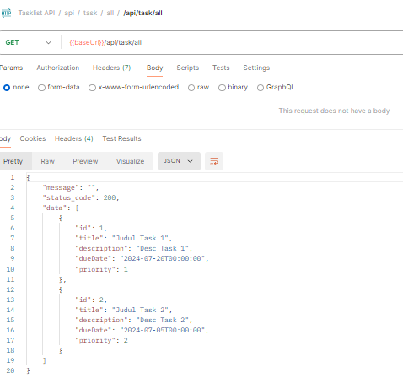

# Create Task

URL: /api/task/create [POST]

Payload:

{

"title": "<string>",

"description": "<string>",

"dueDate": "<dateTime>",

"priority": "<integer>"

}

Scenario:

* Some fields are null or blanks
* All fields are filled

Testing Validation:

If we blank or make null to one or some fields

Payload:

{

"title": "",

"description": "",

"dueDate": null,

"priority": null

}

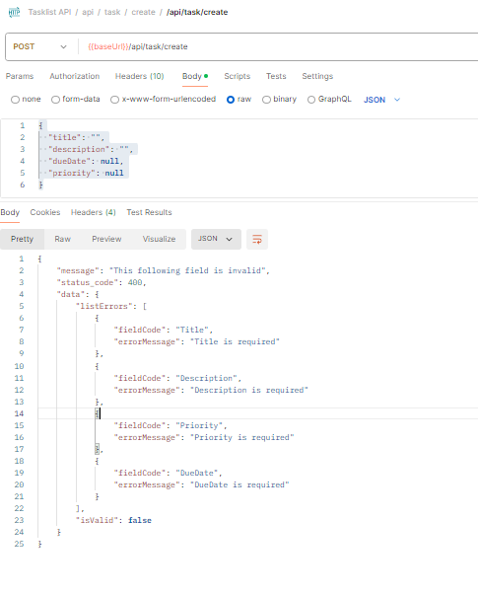

If the form field is valid

With sample payload:

{

"title": "judul 1",

"description": "judul 1",

"dueDate": "2024-07-20",

"priority": 1

}

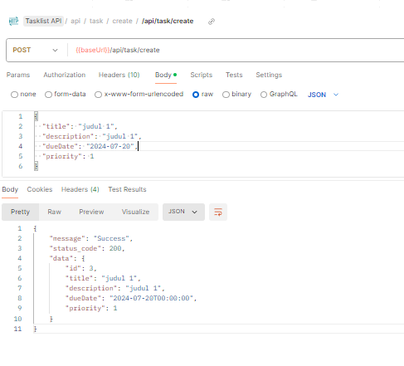

Then call Get All API, the data is inserted at the last id

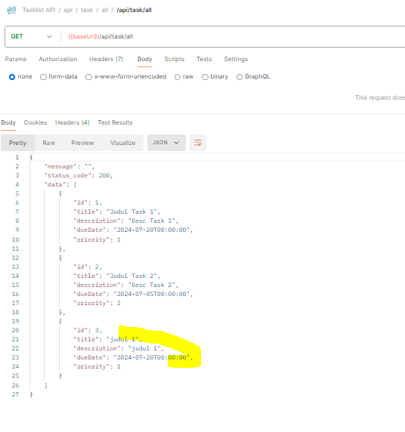

# Edit Task

URL: /api/task/edit/:id [PUT]

:id is numeric (eg. 1, 2, 3, etc)

Payload:

{

"title": "<string>",

"description": "<string>",

"dueDate": "<dateTime>",

"priority": "<integer>"

}

Scenario:

* If id is not registered
* Some fields are blank/null
* All fields is filled

Testing Validation

If Id is not registered

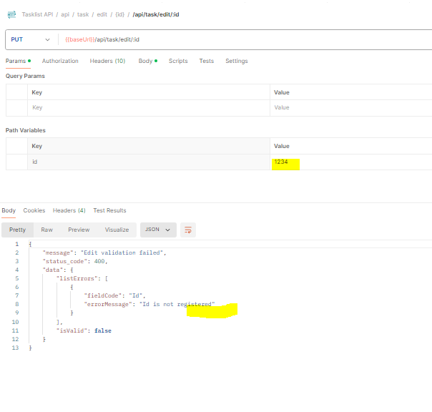

Then, fill the id with the registered id. If some field are blanks

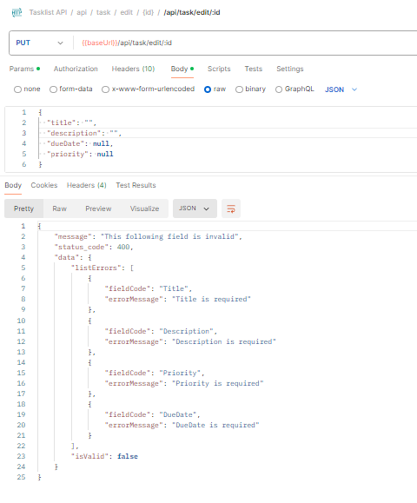

Then fill the data, for example the id is 2 to be updated

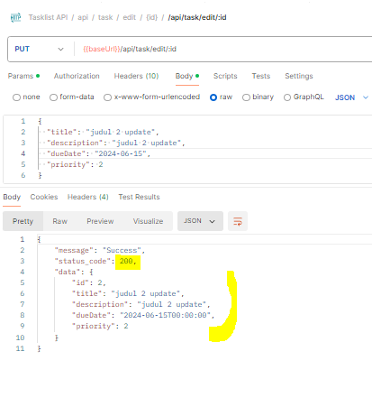

Then check at get all

This field is updated

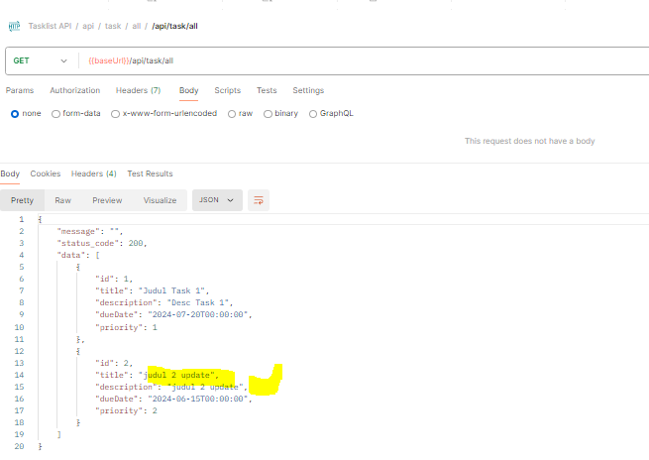

# Delete Task

URL: /api/task/delete/:id [HTTPDELETE]

Scenario:

* If id is not registered
* Id is registered

If Id is not registered

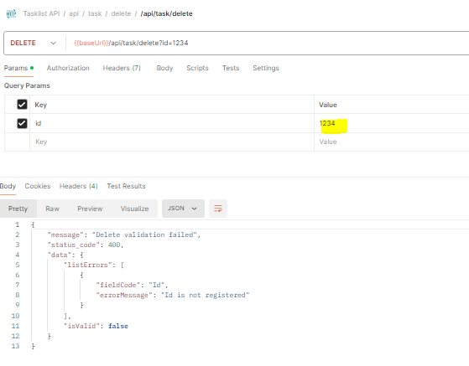

Is Id is registered, then post

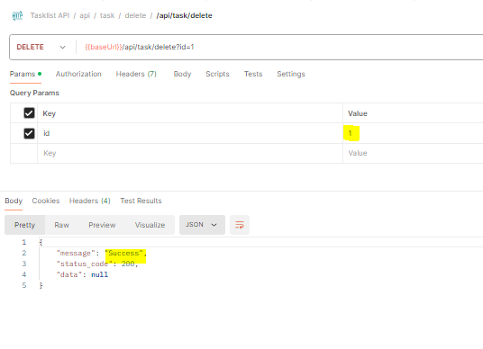

Cek get all, the id=1 is disappear

